CNSL Lab Assignment 2
Neeti Kurulkar
Demonstrate the different types of topologies and transmission media by using a packet tracer tool.

Topologies:
- Bus Topology

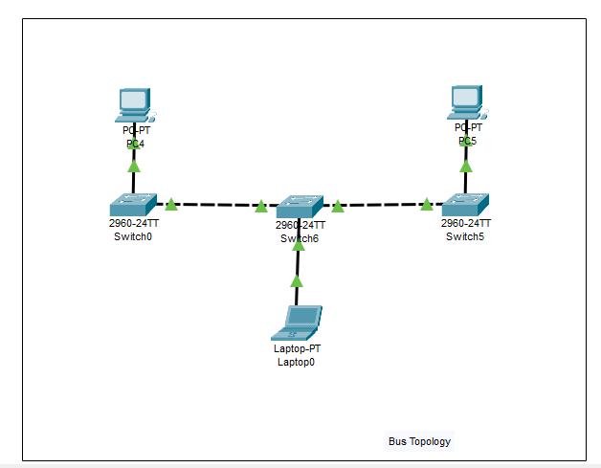

- Star Topology

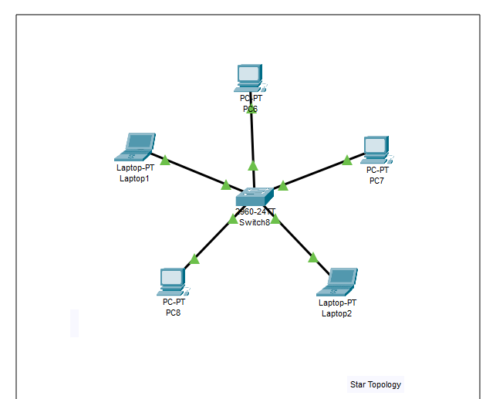

- Ring Topology

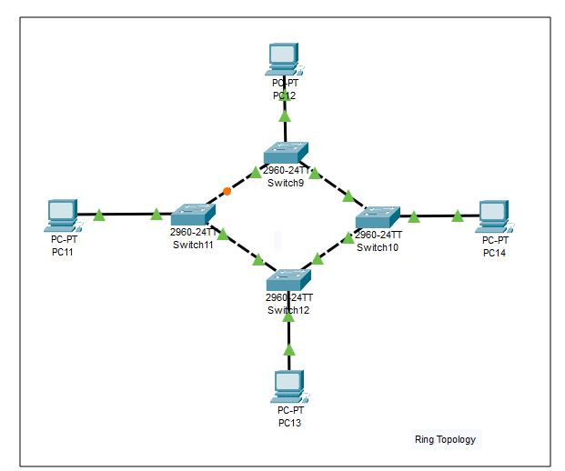

- Mesh topology

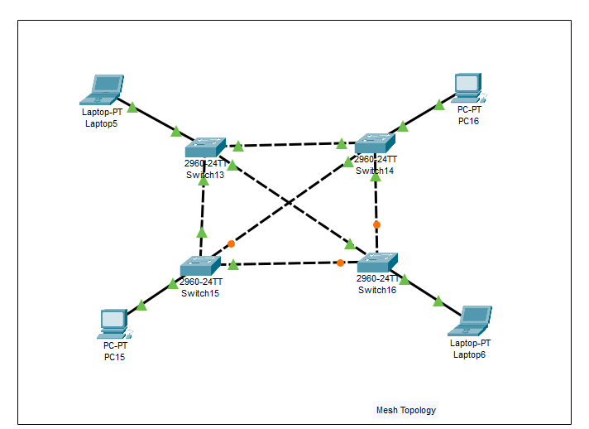
- Hybrid Topology

